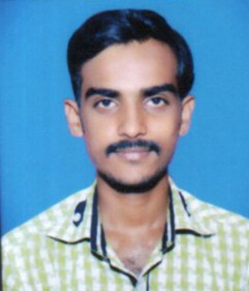

Akshay Ashok Debadwar
Padmavati Galli , Parli Vaijanath Pin-431515
Dist.: Beed
Contact no.: +91-8605699033
Email ID: debadwarakshay@gmail.com

Career Objective:
To work for an organization which provides me the opportunity to improve my skills and knowledge to growth along with the organization objective.

Educational Qualifications:

- Education: Bachelor of Computer Application (Pursuing).
- Institute: Yogeshwari Mahavidyalaya , Ambajogai.

Semester | I | II | III | IV | V | VI | CGPA
SGPA | 8.10 | 7.68 | 6.94 | 7.64 | 7.57 | 7.82 | 7.00
Semester Performance: CGPA-: 7.00

Class | Year Of Passing | Board | Percentage
HSC | 2013 | Aurangabad Board | 49.60%
SSC | 2011 | Aurangabad Board | 49.45%

Projects:

- College Getpass Management System.
- Institute Management System.

Skills Set:
Programming Language: C
Software used : VB.Net 2010.
Working Platforms : Windows , MS-DOS

Achievements:
- Got 1st Prize in Graduation Agreegrate In my caste.
- Got 2nd Prize in No backlog in three year.

Extra-Curricular Activities:

- Participated in social work management.
- Participation in seminar prasentation.

Personal Details:
Father’s Name: Mr. Ashok Pandharinath Debadwar
Mother’s Name: Mrs. Sunita Ashok Debadwar
Date of Birth: 26th July 1996
Languages Known: Hindi And Marathi.

Hobbies :
- Travelling
- Tracking
- New Things Any Filds
- Listening to music

Declaration :
I, undersigned hereby declare that the above given information is true to the best of my knowledge.
Place: Parli Vaijanath

Date: Akshay Ashok Debadwar

